UNIVERSITY OF THE EAST

Rating
152 Samson Road, Caloocan City
College of Engineering
Information Technology Department

CCS2102 – OBJECT ORIENTED PROGRAMMING
Laboratory Activity 5

Name |  | Section:
Student Number |  | Professor: | Celis, J. R. E.

INSTRUCTIONS:
- For each problem, paste the code and sample output here.
- Make sure your name and student number are printed at the end of the output.

EXAMPLE:

Sample Problem:

Create a program that accepts two numbers, then displays the sum, difference, product, and quotient.

Code: Sample Output:
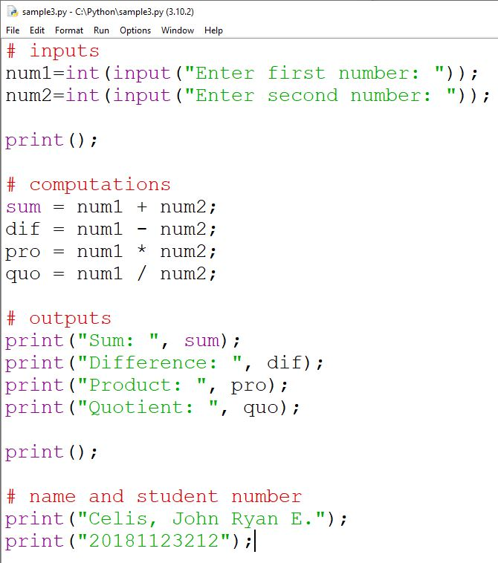
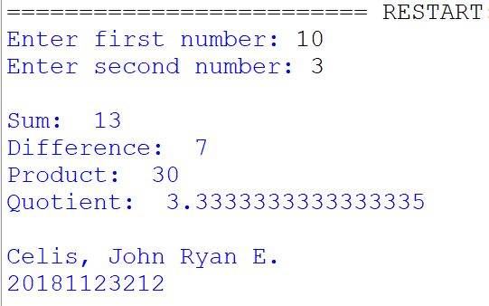

Problem:

Create a C++ program that will input the following:
- Employee Name
- Position Code
- Tax Code
The program will output the following:
- Employee Name
- Position Code Equivalent
- Tax Code Equivalent
- Gross Pay
- Net Pay
Based on the following:
- Position Codes:
  - M = “Manager” (Gross Pay of Manager is 50,000)
  - S = “Supervisor” (Gross Pay of Supervisor is 35,000)
  - R = “Regular” (Gross Pay of Regular is 25,000)
  - C = “Contractual” (Gross Pay of Contractual is 15,000)
  - Other letter = “Unknown” (Gross Pay of Unknown is 0)
- Tax Code Equivalent:
  - A = 10% tax
  - B = 20% tax
  - C = 30% tax
  - D = 40% tax
  - Other Letter = 0%
- Gross Pay is based on the entered Position Code
- Net Pay is Gross Pay minus the tax based on the entered tax code

NOTE:
- Make sure that you write the program based on Classes, Objects, and Methods.
- Make sure you implement Setters and Getters.
- Update your Journal to include this laboratory activity.

For live preview, download the program here:
https://drive.google.com/file/d/1G64lq6iAgTcE5AGjDgn9dwO9Gg-DaNAh/view?usp=sharing
Note: Your browser, anti-virus, or operating system may consider this file as a virus because this is an executable file.

